40.14: According to Eq.40.17, the wavelength of the electron inside of the square well is given by
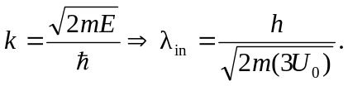
By an analysis similar to that used to derive Eq.40.17, we can show that outside the box
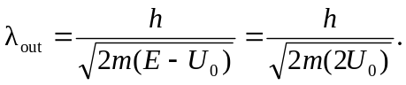
Thus, the ratio of the wavelengths is
